**How Clean Are My Surroundings ???**

**Year 9 Investigation**

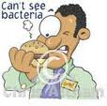Name: ______________________ Due: ____________________

Microorganisms surround us!! They thrive on our hands, faces, our mobile phones, our desks, bags….. the surfaces we are in contact with contain many millions of colonies of microorganisms.

**Personal hygiene** such as washing hands is recommended as a way of reducing the spread of bacteria. Sprays, disinfectants and antiseptics are used to further reduce the growth of colonies of bacteria in the places we eat, work and interact.

The purpose of this investigation is to determine the number of micro-organisms on different surfaces at our college.

The presence of bacteria can be demonstrated by pressing the cotton bud onto the surface of a thin layer of agar jelly sitting in a Petri dish (this is called a culture plate). The agar contains nutrients for any micro-organisms that may grow on its surface.

After the sample is plated onto the agar, the plate can be incubated (kept in a warm place or in an incubator) for several days.

Bacteria that are transferred to the agar will reproduce to form colonies that can be seen. The more colonies, the more bacteria there are present.

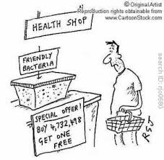

**The purpose of this investigation is to compare the bacteria present on different surfaces**

* **Suggested materials** – petri dish containing agar, cotton buds/swabs, sticky tape, marker pen, incubator.
* You will work in a small group to plan the investigation then carry it out. Please write the report individually.

**SAFETY NOTE: Once the bacteria are transferred onto the agar, the petri dish MUST be sealed shut with tape and not re-opened.**

Name:_____________________________ Class:________________

Due Date: ____________

|  |  |  |  |
| --- | --- | --- | --- |
| **Part** | **Details** | **Available**  **Mark** | **Your**  **mark** |
| Title  Aim  Introduction | Descriptive NOT Biology Investigation  Types of microorganisms  Labelled diagram  Best conditions for micro-organisms | 1  1  1  2  2 |  |
| Hypothesis | Correctly worded  Includes dependent and independent variables | 2 |  |
| Materials | Complete  Listed | 2 |  |
| Method | Step by step with numbers  Written in past tense  Complete  Labelled Diagrams | 1  1  1  2 |  |
| Results | Tables - neat & clear information  All data is recorded  Diagrams  Results summary | 3  2  1 |  |
| Discussion | Errors  Effects of errors  Solutions explain how more reliable results are achieved | 1  1  2 |  |
| Conclusion | What did the results show?  Use figures from your results  Does this support your hypothesis?  Suggest a concise conclusion about bacteria in the school – give Scientific reasons | 1  1  1  3 |  |
| Recommendations | What recommendations can be made about changing environments at Aranmore College from your results | 2 |  |
| **Total** | | **34** |  |

TITLE :

**Aim:**

**Introduction**:

What are some types of microorganisms?

________________________________________________________________________________________________________________________________________________________________________________________________________________________________________________________________________________________

Label the Diagram of a Bacteria

[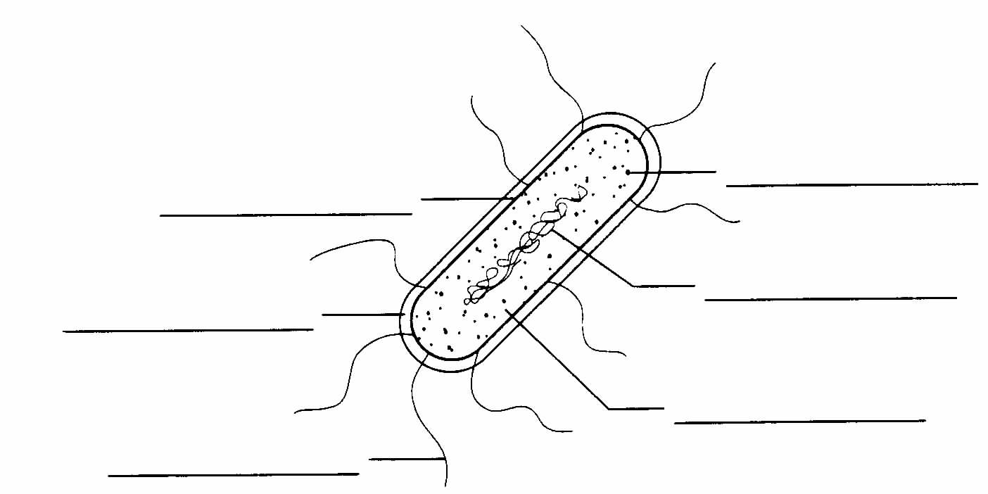](http://www.google.com.au/url?sa=i&rct=j&q=&esrc=s&frm=1&source=images&cd=&cad=rja&docid=EOU9_x4lxI_2sM&tbnid=q70lwV7dYtSzdM:&ved=0CAUQjRw&url=http://ohs-bio.www1.50megs.com/ch17/Chapter%2017%20Worksheet-2.htm&ei=lFpvUaPSIoehkAWa4IHABA&bvm=bv.45368065,d.dGI&psig=AFQjCNGCfQQCYpvRcYNVd7TMc_uqVJUHuA&ust=1366338568969798)

What are the best conditions to grow bacteria ?

* ________________________________________________________________
* ________________________________________________________________
* ________________________________________________________________
* ________________________________________________________________

**Hypothesis:**

**Independent variable: (manipulated/ changed)**

**Dependent variable: (measured)**

**Materials:**



**Method:**



**Results:**

|  |  |  |
| --- | --- | --- |
| Surface Tested | Agar Plate 1 |  |
|  |  |
|  |  |
|  |  |
|  |  |
| Agar Plate 2 |  |
|  |  |
|  |  |
|  |  |
|  |  |

**Diagrams:**

**Summary - What your group results show:** _______________________________________________________________________________________________________________________________________________________________________________________________________________________________________________________________________________________________________________________________________________________________________________________

Recall the Hypothesis: (What your group was testing)

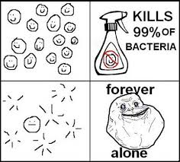

**Discussion:**

Problems encountered in the experiment:

Effects of experimental errors:

How could the experiment be improved to create a more reliable & rigorous/better test?

**Conclusion:**

What did your results show:

Data from our results:

Is the hypothesis supported?

Suggest a conclusion about your study of micro-organisms/ bacteria in the school – give Scientific reasons:

**Recommendations:**

From your study what recommendations can be made about environments at Aranmore College?

